Products and services of the future in an African context | September 30  2015
Banking products and services have evolved significantly over the years. Technology, regulation and globalisation all contribute to the creation of new markets and product or service opportunities. This paper seeks to unravel what products and services the market will be looking at in the next 5-7years and the opportunities available for Barclays to capture growth in this market.

GROUP 8

Table of Contents
1.0 Introduction 2
2.0 Energy in Africa 3
2.1 Background 3
2.1 Barclays background 4
3.0 The Solution 5
3.1 Distributed Energy Resources 5
3.2 How will it work? 6
3.3 Dynamics 6
3.4 Returns 7
3.5 Core benefits for Barclays 7
3.6 Core benefits for Africa: 8
3.7 Risks 8

1.0 Introduction
The idea of this project topic is for it to be implementable in 5-7 years, which is not that long into the future. The African future specifically has been set in motion already by measurable demographic changes occurring right now: a growing population (13% over 5 years) with a youth bulge that is largely unemployed, urban development and migration, commercial agriculture growth, technology adoption - mainly in the mobile space - and pressure on short-supply resources (e.g. clean fresh water)

The ability to meet these needs depends on the work of public and private sectors to enable socially and environmentally sustainable economic growth.

This makes our goal centered on bottom-up growth: engaging the marginalized and poor population, creating mutually beneficial opportunities and leaving them better off, (socioeconomically and environmentally) than before at completion.

One solution is the lending of our capital resources, project management skills, operational efficiency and well-informed advice - from a business, financial and regulatory background - to the renewable energy sector.

By improving on coverage and stability and reducing the cost of electricity, the project aims to meet the increasing demand from more urban consumers, technology adoption and small and commercial enterprise growth. It will also provide for rural areas without power, drastically improving production and their standard of living with the use of artificial light and appliances. (Talking about sewing machines, lights to study and work at night, tools for crafting and the internet)

2.0 Energy in Africa

2.1 Background
Electricity coverage in Africa lags far behind the rest of the world, as seen in the figure below.

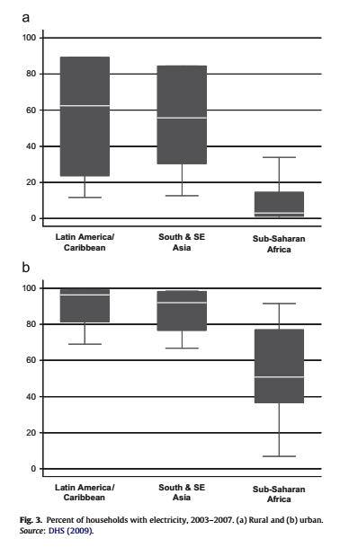

The next figure shows the clear link between GDP and electricity consumption. There is a dynamic two-way connection. (1) Access promotes growth and increase economic production, improves education, and provides better means for healthcare. (2) Higher production requires higher energy consumption. One cannot exist without the other. Therefore, the shortage of electricity supply in Africa directly inhibits our growth.

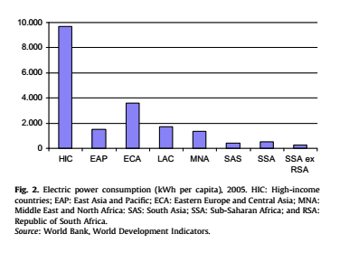

Plenty of solar energy available - much more energy than we need, just need to capture it. See below.

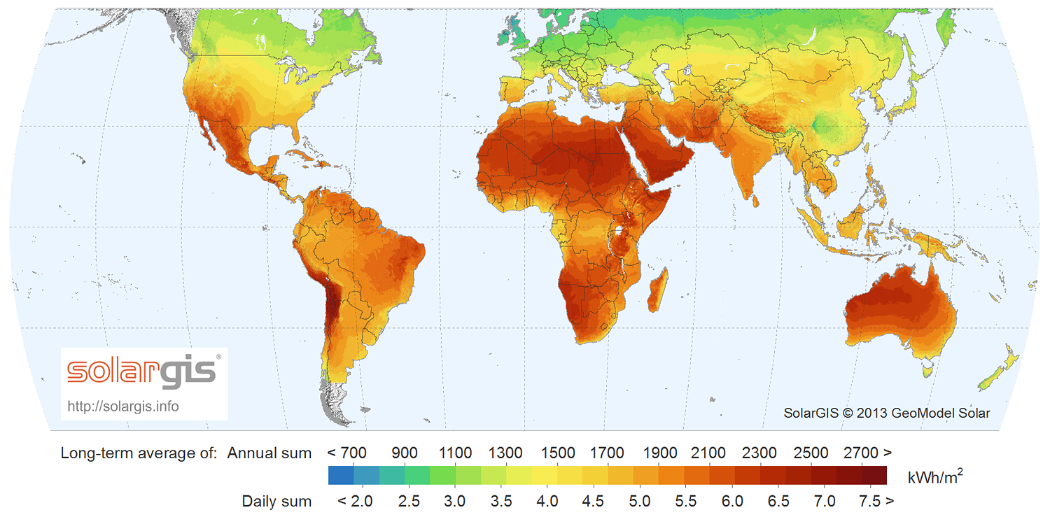

2.1 Barclays background
Barclays is strategically placed right now to leverage its large footprint on the continent, its infrastructure to facilitate customer engagement, payments, lending and insurance, and its role as a business powerhouse (to engage with political stakeholders, large corporations and logistics)

This idea also feeds into the core Barclays value of stewardship and a serves to fulfill almost every aspect of citizenship. Barclays Africa strategy is long term and this project has a highly significant long-term aspect: (1) the formation of a strong industry for Africa that could serve the earth for hundreds of years, long after fossil fuels are depleted and (2) the provision of sufficient energy as demands grows and other supply forms become more expensive and slowly deplete. This is also a huge security point: there will be less need to fight over resources if energy can still be harvested.

We presume that the impact would extend to the green index, global reputation as a leader in customer centricity, environmental concern and Musk-like futurism - taking us a step toward a better future.

3.0 The Solution

3.1 Distributed Energy Resources
Electricity can be centrally generated and distributed throughout a grid. Alternatively, generation can be decentralized and distributed through smaller microgrids. Research suggests that solving the electricity coverage problem will require 100% of distributed generation sources or distributed energy resource (DER).

DER: an electric power generation source connected directly to the distribution network on the customer side of the meter. This includes solar, wind, hydro and biogas power.

Private sector engagement in the DER space can reduce costs. The reduction of cost in a DER is two-fold: (1) reducing cost of transporting the source (gas, biofuel, diesel, coal etc.) since you don’t have to transport sunlight, and (2) cutting distribution costs by not having to send electricity across large distances (transmission lines). (Private sector can also do all of the above at a much more efficient rate than the state)

Further advantages of renewable energy as a DER, as opposed to most development projects (especially electricity generating ones):
- short construction times
- small sizes (helps at the start, don’t need economies of scale to initiate project)
- flexibility (allows for different types of customers, different places, different needs)
- expandability (will help later on as scale improves)

3.2 How will it work?
The process below describes how the capital be paid back and return on capital earned on each project:

- Each component will have an estimated monthly output, depending on the time of the year etc.
- An initial portion of that output, depending on size of project, risk etc. will be ours to sell as the monthly ‘loan’ payment
- For the remaining portion, the owner will receive credits per month, slightly lower than what we can sell electricity for, from Barclays to either use as electricity OR
- The consumer can spend the credits on a Barclays rewards card

Example:
Produce 5kWh per day
Barclays requires minimum 3kWh per day to sell as income for the financing
Customer receives 2kWh of credits - say this is R20
Customer doesn’t use it electricity
Barclays takes 2kWh and sells to buyer for R22, making R2 margin

3.3 Dynamics
- Buyer - By combining the electricity from many DER’s we have bargaining power with the central grid and the regulator/state
- Supplier - Using our network and lending strucutre, we can more efficiently sell DER’s to consumers than solar companies, and can partner with them (e.g. solar panels with a home loan or to a community Co-Op)
- No substitutes - no available capital for consumers to purchase relatively expensive DER technology
- Barrier to new entry - once we begin scaling, the bargaining power, and the extent of out secondary market would be a natural barrier.

Note: Barclays could either sell our credits directly back into the grid or alternatively in a secondary market, such as the figure below describes:
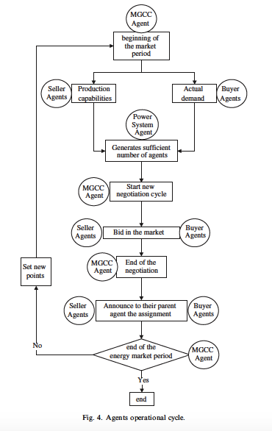

3.4 Returns
Need to do some financial analysis. However, from research I can tell you that the cost of solar energy per kW is currently dropping very rapidly while oil prices are so low. Ironically, cheaper fossil fuel energy is making renewables more of an option.

3.5 Core benefits for Barclays
- Currency return through selling electricity

- Economic returns through providing electricity to small and medium enterprise, creating growth opportunity -> more clients and customers and expanding rewards

- Ownership of the platform -> usage data would then be ours -> other energy companies would want to buy in for electricity distribution
- Reputation/goodwill.

3.6 Core benefits for Africa:
- Expand coverage meeting the energy demands of the continent (hitting all the other notes on education, business and growth)
- Turning it into an African industry, a hard currency for consumers, into electricity for households and businesses and communities, and a
- Create an open-market energy economy for clean electricity - “the liberalisation of the electricity market and increased environmental concerns both induce an increased interest in distributed generation applications and thus also in innovations in the appropriate technologies.
- Diversification of energy supply

3.7 Risks
- Financial, business and operational risks.
- Regulation and political risks.
Key assumptions to make
- Learning curve for solar PV - making panels, distributing and installing, maintaining and R&D (essentially the entire industry)
- Smart meter usage can overcome challenges of the incorporating microgrids into main grid, or even independent houses into the grid.
Policy issues
- Market restriction
- Buy-back price is low
- Charging high prices for services
- Regulation - can get them on board?
System security
- system frequency and voltage- maintained by transmission grid (usually the regulator)

